Molecular Insights into Host Use and Pathogen Acquisition by an Insect Vector in Potato Crop Fields

Camille Wagstaff¹, Jillian J. Foutz^{1, 2}, W. Rodney Cooper², Riley M. Anderson¹, David W. Crowder¹

¹ Washington State University, Department of Entomology, Pullman, Washington 99164, USA
² USDA ARS Temperate Tree Fruit and Vegetable Research Unit, Wapato, Washington 98951, USA

Corresponding author details:
Camille Wagstaff
Washington State University, Department of Entomology, Pullman, WA, 99164, USA
Camille.wagstaff@wsu.edu
Abstract:
Generalist insect vectors are notoriously difficult to manage due to their ability to use a range of host plants within and across seasons. Improving vector management requires novel approaches that assess host use across space and time to better predict pathogen transmission dynamics. Molecular gut content analysis of vector insects has been instrumental in identifying host use but has often been poorly linked with hosts related to pathogen transmission. Here, we integrate gut content analysis with monitoring of pathogen incidence to determine the role of various hosts in Neoaliturus tenellus (previously Circulifer tenellus Baker) (beet leafhopper) movement and pathogen spread. We tested 230 beet leafhopper adults collected from 15 sites over three years to assess host use and pathogen acquisition. Our results show that N. tenellus likely acquire pathogens from Sisymbrium spp. and Brassica spp. (wild mustards) in spring, while Salsola/Kali spp. (Russian thistle) and Bassia spp. (kochia) are primary N. tenellus hosts during the summer. A new discovery, we detected N. tenellus use trees as hosts, including Tilia spp. (linden), Prunus spp./Pyrus spp. /Citrus spp (fruit), and Tsuga spp./Pinus spp, (pine). Our study refines our understanding of N. tenellus ecology and highlights the importance of host use patterns in predicting pathogen transmission, ultimately improving pathogen risk assessments.

Keywords: gut content analysis, beet curly top virus, purple top disease, phytoplasma, landscape ecology, pest population dynamics, vector monitoring
Introduction:
Many insect pests that are vectors of pathogens are generalists that feed on diverse hosts across landscapes and seasons (Weintraub and Beanland 2006; Gutiérrez-López et al. 2020). Generalist vectors are notoriously difficult to manage due in part to their ability to move between different crop types and non-crop weedy hosts (Nault 1997; Heck 2018; Gutiérrez Illan et al. 2020). Areawide management is challenging to coordinate, and large patches of weedy hosts are often unmanaged nearby commercial production areas, providing sources of vector populations at variable points during crop seasons (Bennet 1971). Pathogens transmitted by vectors also have variable ability to attack different host species, and these infectivity traits may not always align with vector host preferences (Thapa and Ghersi 2023). A comprehensive understanding of host use by vectors and pathogens is key for predicting vector and pathogen dynamics and forecasting disease outbreaks while also aiding in developing mitigation strategies.
Effective vector management requires innovative approaches to assess host use over space and time to understand pathogen transmission dynamics (Rafter and Walter 2020). One emerging technique to assess insect host use is molecular gut content analysis, which identifies ingested plant DNA within insect digestive systems to reconstruct trophic interactions (Cooper et al. 2019; Cooper et al. 2022; Pitt et al. 2024). When molecular gut content analysis is used with structured surveys of insects across broad regions, the technique can infer patterns of insect movement across broad landscapes within and across seasons (Cooper et al. 2019; Strausbaugh et al. 2024). While gut content analysis cannot directly establish a link between vector feeding events and pathogen acquisition, integrating gut content analysis with pathogen incidence data could clarify the relationships between host use and pathogen spread. However, relatively few studies have assessed both vector gut content analysis and pathogen incidence on various hosts.
The ecology of many insect vectors, such as the beet leafhopper (Neoaliturus tenellus Baker; Hemiptera: Cicadellidae), is often largely based on natural history surveys or structured surveys of agricultural systems (Brewster and Allen 1997; Damos 2015; Wohleb et al. 2021). However, for many vectors, the plant hosts that serve as pathogen reservoirs, and thereby pose the greatest risk to crops, are largely inferred rather than directly known (Horton et al. 2018). For example, it may often be assumed that most hosts used by a vector will also be hosts for pathogens transmitted by that vector, or that hosts will be a predictable subset constrained by plant phylogeny (Perilla-Henao and Casteel 2016). Molecular tools are an effective way to bridge this knowledge gap, as the same insects can be tested for the pathogens they carry as well as their prior host use (Cooper et al. 2019; Cooper at al. 2022; Pitt et al. 2024).
Here, we leveraged molecular gut content analysis to trace landscape-scale movements of N. tenellus in a major potato production region, the Columbia River Basin region of Washington State, US. As the sole vector of Beet curly top virus (BCTV), Candidatus Phytoplasma trifolii (CPt) (priorly known as Beet leafhopper-transmitted viresence agent (BLTVA), and Spiroplasma citri (S. citri), N. tenellus facilitates pathogen spread across cropping areas throughout the season (Cooper et al. 2023). Previous monitoring suggests that wild Brassicaceae species serve as overwintering reservoirs, while Amaranthaceae species support leafhopper populations during the growing season (Horton et al. 2018). However, it is still relatively unknown which non-crop and crop hosts are most associated with pathogens. Over three years, we analyzed 230 adult N. tenellus collected from 15 sites across the Columbia Basin to determine seasonal host use and pathogen incidence. This knowledge can enhance targeted control measures and mitigate crop losses associated with leafhopper-borne pathogens and associated crop diseases.

Materials & Methods:
Study system
Leafhopper-transmitted pathogens threaten many crops in the western United States, including potatoes and seed crops such as sugar beet, carrot, spinach, and hemp (Soto and Gilbertson 2003; Munyaneza et al. 2006a; Rondon and Murphy 2016; Nachappa et al. 2020). Gut adaptations of N. tenellus allow pathogens to traverse the stomach lining and colonize within salivary glands, facilitating transmission (Knowlton 1929; Suzuki et al. 2006; Frantz et al. 2023). Further, N. tenellus does not exhibit strong host specificity, often feeding on hosts that cannot fully support development, and the persistence of pathogens are closely linked to the life cycle and migratory behavior of N. tenellus (Thomas and Boll 1977). Overwintering females lay eggs in spring, and nymphs acquire pathogens from weedy host plants before dispersing into agricultural fields (Meyerdirk and Hessein 1985; Meyerdirk and Moratorio 1987; Lee et al. 2022). Populations tend to establish on weeds in the Brassicaceae family in spring, but as temperatures rise in mid-April and these weed hosts dry out, N. tenellus disperse into summer crops (Munyaneza et al. 2006b; Horton et al 2018). This movement plays a role in pathogen transmission, yet how host use relates to pathogen prevalence remains poorly understood. To better characterize seasonal host use of N. tenellus and its role in pathogen transmission, we conducted molecular gut content analysis.

Site Selection and Sampling
Sampling was conducted at sites across the Columbia River Basin during the 2019 and 2020 growing seasons and in spring of 2021 (Fig. 1). Most sites were included in the Washington State University’s potato pest monitoring network, a standardized sampling network on commercial farms; additional sites were at university research farms. In 2019 and 2020, sampling focused on irrigated potato fields and adjacent weedy areas, while in 2021 collections occurred near potato fields before planting (Fig. 1). Our approach aims to identify key plant species that may serve as hosts at different times of the year, and plant tissue samples from collection sites were tested for the presence of pathogens to assess potential sources of infection (Foutz et al. 2025). Linking vector gut content analysis with pathogen incidence may resolve host-pathogen interactions and improve predictive models for disease outbreaks (Cooper et al. 2019).
Sampling occurred every other week in 2019 and 2020 and weekly in 2021. Insects were collected using a reversible leaf blower into organdy bags and transferred to resealable plastic bags (26cc Gas Handheld Blower Vacuum, Homelite Corporation, Charlotte, NC). All potential weedy host stands within 100 m of potato fields were sampled for one minute per plant stand. Additionally, five leaves per sampled stand of weeds or potatoes were collected for pathogen testing (Foutz et al. 2025). Live insects and plant samples were transported on ice and immediately frozen at -40 °C upon arrival at the laboratory. Identification and sexing were performed under a stereo microscope using distinct morphological traits of tapered, bullet body shape measuring 3 to 4 mm in length, with a pale green to tan coloration, and specimens were stored in a -40 °C freezer.
Of the 1,765 adult N. tenellus collected across the Columbia Basin from 2019 to 2021 in this manner, 230 N. tenellus from potato fields were selected for gut content analysis. Initially, we surveyed infection status based on the host plant species from which leafhoppers were collected. In 2019, a total of 64 N. tenellus individuals were selected from kochia, potato, russian thistle, pigweed, and mustards. This sub-sample revealed minimal infection incidence, limiting our ability to detect viable host reservoirs. Consequently, in 2020 a total of 93 N. tenellus individuals were selected based on infection status. Gut content analysis was performed on 24 BCTV-infected leafhoppers, 25 CPt-infected leafhoppers, 23 leafhoppers co-infected with both BCTV and CPt, and 25 healthy or non-infected leafhoppers. Current hypotheses are that leafhoppers obtain pathogens from weeds used in overwintering and that the greatest threat to crop infection may be in spring as leafhoppers transition from overwintering hosts to new crop growth (Horton et al. 2018). To explore the validity of the spring migration hypothesis we focused our sampling in 2021, to include 73 individual beet leafhoppers collected in spring and early summer.

DNA Extraction
Adult N. tenellus were surface sterilized by sequentially immersing them individually in 70% ethanol for 5 seconds, sterile deionized water for 5 seconds, followed by a 60-second treatment in 1% bleach, and two final 5 second rinses in sterile deionized water. Specimens were then air-dried on Kimtech Science™ Kimwipes™ placed within a sterile petri dish. Total DNA was extracted using the DNeasy Blood and Tissue Kit (Qiagen, Hilden, Germany) following the manufacturer’s protocol. All extraction procedures were carried out in a UV-sterilized biosafety cabinet. To assess DNA quality and concentration, a subset of samples were evaluated using a Nanodrop spectrophotometer (ThermoFisher Scientific, Waltham, MA). Negative controls lacking DNA templates were included throughout the analysis process. All extracted DNA samples were stored at -20 °C until further molecular procedures were carried out.

Pathogen Identification
Testing for the presence of CPt in insects was done using real-time PCR on a Lightcycler 480 (Roche, Basel, Switzerland) with these conditions: a 5 min hold at 95 °C, 20 cycles of 95 °C for 10 sec, 65 °C for 10 sec, and 72 °C for 10 sec, then 20 cycles of 95 °C for 10 sec, 55 °C for 10 sec, and 72 °C for 10 sec, a melting curve to assess primer specificity, and a cooling cycle. Each 20 μL reaction contained 10 μL of SYBR™ Green PCR Master Mix (ThermoFisher Scientific, Waltham MA), 8.2 μL of nuclease-free water, 0.4 μL each of Ca. P. trifolii primers “z-R16R2-wfB_F” (AAA TAT TTC TCG GGG TTT GTA CAC ACC GCC CGT CA) and “BLTVA-int-wfB_R” (AAT TAT CTC TGA TGA TTT TAG TAT ATA TAG TCC) at 20 μM concentration, and 1 μL of extracted N. tenellus DNA (Cooper et al. 2023, Swisher Grimm et al. 2023).
Testing for the presence of BCTV was by conventional PCR on a BioRad thermocycler with these conditions: 1 min at 95 °C, 20 cycles of 95 °C for 15 s, 65 °C for 30 s (touchdown, Δ−0.5 °C), and 72 °C for 20 s, then 20 cycles of 95 °C for 15 s, 55 °C for 30 s, and 72 °C for 20 s, then 1 min at 72 °C before an infinite hold at 4 °C until samples were removed. Each 20 μL reaction contained 10 μL of Amplitaq Gold 360 Master Mix (ThermoFisher Scientific, Waltham, MA), 8.6 μL of nuclease-free water, 0.2 μL each of primers “BCTV2-F” (GTG GAT CAA TTT CCA GAC AAT TAT C) and “BCTV2-R” (CCC ATA AGA GCC ATA TCA AAC TTC) at 20 μM concentration, and 1 μL of extracted N. tenellus DNA (Strausbaugh et al. 2008, Swisher Grimm et al. 2023). Infection was confirmed by visualizing approximately 520-bp PCR products under UV light on a 1% agarose gel stained with GelRed (Biotium, Fremont, CA).
Samples from 2019 and 2020 were also tested for Spiroplasma citri, another plant pathogen transmitted by N. tenellus, using conventional PCR with conditions identical for BCTV. Each 20 μL reaction contained 10 μL of Amplitaq Gold 360 Master Mix, 8.6 μL of nuclease-free water, 0.2 μL each of primers “S.citri-1” (GGT CTG CTG CTT TAA TTT CTA C) and “S.citri-2” (TGC AGC ACC TGC AAC TGT AG) at 20 μM concentration, and 1 μL of extracted N. tenellus DNA (Cooper et al. 2023, Swisher Grimm et al. 2023). S. citri infection was determined by visualizing the 350-bp PCR products under UV light on a 1% agarose gel with GelRed staining. Only 8% of tested samples showed infection, and this pathogen was left out of further analysis.
For molecular pathogen detection in this study, we used real-time PCR as presence/absence data was sufficient to address the study’s research objectives. DNA concentrations were not standardized across samples; therefore, Cq values are not reported, as they do not accurately reflect pathogen titers in insect tissues (Ruiz-Villalba et al. 2021).

Molecular Gut Content Analysis
The dietary profiles of N. tenellus were investigated using high-throughput, single-molecule real-time (SMRT) sequencing on the PacBio sequencing platform. Plant-derived DNA was amplified from individual insect gut extractions using primers targeting two common plant barcoding loci: the chloroplast trnF region and the nuclear internal transcribed spacer 2 (ITS2). PCR amplification was conducted separately for each locus using universal primers: trnF (B49873-e: GGTTCAAGTCCCTCTATCCC; A50272-f: ATTTGAACTGGTGACACGAG; Taberlet et al. 1991) and ITS2 (ITS2F: ATGCGATACTTGGTGTGAAT; ITS3R: GACGCTTCTCCAGACTACAAT; Chen et al. 2010). To enable numerous samples to be sequenced in the same pooled set (Pacific Biosciences, 2014), each sample was assigned a unique combination of asymmetric barcoded forward and reverse primers as described in Cooper et al. 2019 and 2022. Reactions were performed in 50 µL volumes, using 40uL Invitrogen Amplitaq Gold 360 PCR Master Mix at 62.5% (Invitrogen, Carlsbad, CA), 250 nM of each primer (or 5 µmol/L of forward and reverse primers), and 5 µL of DNA template.
Thermocycler conditions for PCR of ITS2 included an initial denaturation at 94 °C for 5 minutes, followed by 35 cycles of 94 °C for 30 seconds, 56 °C for 30 seconds, and 72 °C for 45 seconds, with a final extension of 5 minutes at 72 °C. For trnF, cycling conditions were slightly adjusted: an initial denaturation at 94 °C for 10 minutes, 40 cycles of 94 °C for 30 seconds, 58 °C (or 52 °C for some optimized reactions) for 30 seconds, and 72 °C for 45 seconds, followed by a 5-minute final extension at 72 °C. Amplicon sizes approximately 500 bp were confirmed through visualization on electrophoresis 1% agarose gels stained with either ethidium bromide or SYBR® Safe (Thermo Fisher Scientific).
The remaining PCR product volumes for pooling were adjusted based on band intensity, and PCR products were cleaned using QIAquick® PCR Purification Kits (Qiagen, Hilden, Germany) prior to pooling. Each pooled sample set included no-template controls (NTCs) containing water and positive controls consisting of psyllid species collected directly from feeding on known host plants, each with their own unique barcode set to monitor contamination and PCR efficiency. The pooled library was concentrated using AMPure XP beads (Beckman Coulter), end-repaired, ligated to SMRTbell adapters with the Express Template Prep Kit v2.0, and quantified prior to sequencing on 1M v3 SMRT cells using the Sequel Binding Kit 3.0. The run was conducted for 10 hours at the Washington State University Laboratory for Biotechnology and Bioanalysis Genomics Lab. Raw sequence data were processed using SMRT Link v6.0 to generate high-quality circular consensus sequences. Demultiplexed reads were filtered to retain only sequences between 400 and 700 bp and with a minimum quality threshold (Phred ≥ 40, inferred accuracy ≥ 0.9999). Sequence data were analyzed using Geneious Prime® (v2023.1.2). Operational taxonomic units (OTUs) were generated via de novo assembly using custom parameters (95% minimum overlap identity, 1% max gaps per read, and 5% max mismatches). OTUs represented by five or fewer reads were excluded to minimize the inclusion of artifacts or potential contamination. BLASTn searches against the NCBI GenBank database were used to assign taxonomic identities, with matches reported to the genus level, not species, for greater reliability (Altschul et al. 1990). A plant taxon was considered present in a sample if at least six reads matched a given OTU, a threshold consistent with previous metabarcoding studies (Cooper et al. 2022). Given that prior research has shown plant DNA signal intensity may not correlate with feeding intensity or time since ingestion, dietary results were interpreted qualitatively as presence/absence data (Avanesyan et al. 2021).

Analytics
Data was evaluated to explore seasonal trends in N. tenellus infection status and variation in host plants found in guts across the Columbia River Basin. The observational nature of this study precluded formal hypothesis testing. Instead, we present a general summary of our surveys to show the variability in infection status, the diversity of host plants used, and the seasonal timing of host plant use by N. tenellus. We considered that variation in host plant species composition may explain differences in infection status and made these comparisons with PERMANOVA (vegan::adonis2) (Oksanen et al. 2024). This approach takes the matrix of species composition as a function of BCTV infection status, CPt infection status, collection region, and collection year as fixed effects and the host plant species that each N. tenellus was collected on as a random intercept. To explore the hypothesis that N. tenellus seasonally migrate from weeds to crops in early spring we included a spline term (df = 5, knots = 0) for the sampling date of each N. tenellus in our PERMANOVA. Significant effects were evaluated by constrained ordination via Canonical Analysis of Principal Coordinates (CAP), a robust method for parsing out complicated effects in multivariate analyses without Euclidean distance constraints (Anderson and Willis 2003). The effect of sampling date was visualized by fitting a generalized additive mixed model (GAMM) surface overlay with smooth terms for the constrained (CAP) and unconstrained (MDS) axes (df = 5) using the gamm4 package (Wood and Scheipl 2020). All multivariate analyses were restricted to the top tenth percentile of species based on abundance. As an alternative approach, we used kernel density estimation and the ggridges package (Wilke 2024) by aggregating the occurrence of each host plant record in N. tenellus guts across all samples. These counts were then aggregated by sampling date and kernel density estimation using Silverman’s rule (Gaussian smooths for small sample size) was used to visualize trends in host plant use over time (Scott 1992). All analyses were conducted in R v 4.2.3 (R Core Team, 2023) and the tidyverse ecosystem (Wickham et al. 2019).

Results
Of the 230 N. tenellus tested for pathogens and molecular gut contents, 113 were uninfectious, 39 harbored only BCTV, 43 harbored only CPt, and 27 carried both BCTV and CPt. Only the N. tenellus collected in 2020 were also tested for S. citri, with 8 out of the 93 being positive. These analyses revealed 2,435 total plant hits, representing 246 plant species, 150 plant genera, and 45 plant families. The majority were non-crop weeds (61%), mainly Bassia, Salsola, Sisymbrium, Amaranthus, and Kali spp. (Fig. 2). The most common hosts were mustards (17.9%), Russian thistle (11.3%), kochia (8.6%), nightshades (5.3%), pigweed (2.7%), lambsquarter (2.6%), and a mixture of other Asteraceae and Amaranthaceae (12.5%). Crops were also found in N. tenellus guts, primarily Raphanus, Cannabis, Medicago, and Vigna (Fig. 2). We also detected multiple tree species, especially Tilia spp. or linden trees (Fig. 2). Across all samples, N. tenellus individuals fed on a median of five plant species, four genera, and three families. However, there was considerable variability among individuals, with some feeding on as many as 20 different species and others on only one. There was greater heterogeneity in species-level feeding with standard deviation highest at the species level (3.92).
Most N. tenellus individuals were uninfectious, and infection status (BCTV, CPt, or both) did not differ across crop types, suggesting a uniform distribution of infectious individuals among crops (F₆ = 0.89, P = 0.50). Neither pathogen infection nor sampling location shaped dietary diversity as the plant community composition in N. tenellus guts was not influenced by CPt infection status (F₁ = 0.72, P = 0.68) or region (F₄ = 1.08, P = 0.60). In contrast, BCTV infection status had a statistically significant but biologically minimal effect on gut plant composition (F₁ = 3.95, P = 0.002). This effect was not due to differences in within-group variability, as confirmed by permutation tests for homogeneity of multivariate dispersions (F = 1.41, P = 0.216, permutations = 999).
Despite the statistical significance of BCTV infection, constrained ordination showed that it explained only 1.0% of the variation in gut content composition. In comparison, the first unconstrained axis (MDS1) captured 24.1% of residual variation (Fig. 3). Further support that BCTV infection may not drive community separation, the plant species vectors aligned primarily along the unconstrained axis, orthogonal to the constrained BCTV axis.
Plant community composition in N. tenellus guts varied significantly across sampling dates (F₅ = 10.20, P < 0.01; Fig. 3), though this effect was collinear with collection year. Variation in gut plant community over time wass further supported by Kernal density estimation. Non-crop weeds were more commonly detected earlier in the season (Fig. 4A), while crop plants appeared slightly later (Fig. 4B), with some exceptions and overlap. However, caution is warranted: some density peaks represent plants detected in only a few individuals, making true seasonal trends in plant consumption uncertain,.

Discussion
Identifying seasonal host plants of N. tenellus can aid in vector movement predictions, reduce the risk of pathogen transmission to crops, and inform targeted management strategies. Gut contents of N. tenellus were primarily composed of non-crop weeds, with non-crop abundance typically one order of magnitude greater than crop or tree abundance. It is well established that N. tenellus feed on a wide variety of plants, with research documenting over 40 commonly used weed host plants that vary across different breeding regions (Douglass and Hallock 1957). In our study, individual N. tenellus contained DNA from 10–20 different plant species, suggesting frequent movement among hosts. However, plant species in the guts of N. tenellus were not defined by infection status with BCTV or CPt, which may represent broad generalism coupled with uniform pathogen dispersion. However, an equally plausible explanation is that hypersensitivity in the molecular tools may have detected trace amounts of ubiquitous plant residues. For example, at the time of sampling, many of the most common weeds (Kali, Bassia, Salsola, Sisymbrium) appeared in 90% of the N. tenellus guts assayed. Despite this alternative hypothesis, we reason that shifts in dietary composition with BCTV or CPt infection may still exist and could be a potential driver of vector behavior and host selection, regardless of our negative results.
By sampling from early spring to late summer, our surveys uniquely capture the seasonal variation in host use of N. tenellus. This seasonal variation lends support for the spring migration hypothesis in that N. tenellus may migrate from early emerging weeds to crops throughout the summer. In early spring, gut contents were marked by peak abundance of non-crop weeds such as Bassia, Descurainia, Sisymbrium, and Lycium. Most crops (Cannabis, Raphanus, Medicago, and Cucumis) were found in peak abundance in late spring to early summer. Some plants were found in N. tenellus during the season at near uniform distributions. Notably, these ubiquitous all-season plants, Salsola and Kali may represent reservoirs for reinfection throughout the growing season, confirming previously published observations (Douglass and Hallock 1957; Munyaneza et al. 2006a; Foutz et al. 2025). Further evidence of host plant species turnover throughout the season was found in our multivariate results, with sampling date representing the majority of variation in species composition that could be explained by our predictors.
Our results suggest that wild mustards, particularly Sisymbrium and Descurainia species, may serve as primary spring hosts for N. tenellus, with peak mustard feeding coinciding with the early-season emergence of nymphs (Foutz et al. 2025). These hosts are essential for N. tenellus development and early pathogen acquisition. Mustards are likely key spring hosts due to their ability to overwinter, cold hardiness, and tendency to germinate earlier than many other weed species (Cici and Van Acker 2011). Our study also uncovered consistent detection of tree species including Tilia, Pyrus, Prunus, and conifers like Pinus and Tsuga, suggesting that trees may play a previously unrecognized role in N. tenellus seasonal ecology. Other research using DNA barcoding has also identified unexpected host plants, including coniferous trees such as Pinus spp. in the diet of N. tenellus, particularly during early summer dispersal events (Cooper et al. 2022, Strausbaugh et al. 2024). These findings further support the idea that leafhoppers may feed on a broader range of plant taxa—including trees—than previously recognized, or they may use trees as part of mating strategies (Cooper et al. 2022). These behaviors have important implications for understanding their movement ecology and the epidemiology of their vectored pathogens (Strausbaugh et al. 2024).
The timing of tree species host use appears to coincide with spring bolting of mustards. While not tested here, this phenology timing event may serve as an important biomarker for growers of tree crops, as trees may serve as temporary or transitional hosts. This pattern of host switching driven by plant phenology may highlight the importance of considering perennial hosts in disease surveillance and management programs. As mustards begin to bolt and turn yellow in spring, they become detectable via satellite imagery, providing an independent line of evidence that correlates with observed patterns of N. tenellus emergence and migration timing (Lee et al. 2025). This phenological cue, visible at landscape scale, suggests that satellite-based monitoring could be used as a predictive tool for vector movement.
We also confirmed strong seasonal patterns in host use. Kochia (Bassia spp.) emerged as a major summer host and pathogen reservoir, with infections persisting into the fall (Foutz et al. 2025), while Russian thistle (Salsola spp.) was the most frequently detected genus overall. Seasonal host shifts appear driven by temperature and host availability, with nymphs showing localized feeding on preferred spring hosts and adults dispersing to irrigated or overwintering hosts in summer and fall (Horton et al. 2018). While plants like Salsola were commonly detected in gut contents and fed on by pathogen-positive N. tenellus, a complementary study showed the plants themselves exhibited low pathogen infection rates (Foutz et al. 2025). This decoupling between vector infection and plant infection highlights complexities in the transmission process and raises questions about vector feeding behavior, host quality, and virus retention. These results suggest that not all frequently visited or consumed plants contribute equally to pathogen amplification and that some may act more as N. tenellus hosts than as true pathogen reservoirs.
While these findings offer important insights, several limitations must be acknowledged. Sampling was not uniform across years, and the observed trend of BCTV-infected N. tenellus having fewer plant species in their gut contents could be linked to the timing of their collection. In the spring, N. tenellus nymphs hatch and develop on infected mustards, remaining relatively stationary until rising summer temperatures kill their preferred weed hosts, forcing migration into irrigated crops (Horton et al. 2018). By fall, N. tenellus begin seeking shelter and identifying suitable overwintering hosts (Horton et al. 2018). This search for an overwintering host may drive more selective feeding behavior, potentially leading to a greater diversity of plants detected in gut content analyses. Additionally, gut content analysis may have potential limitation due to primer specifity of the DNA barcoding primers used, which may bias results toward certain genera. To address this, we used two primer types, ITS2 for broad taxonomic identification and trnF for targeting specific weed species. Additionally, we validated results at the genus level. Despite these precautions, some low-abundance hosts may be underrepresented, and additional analysis with more leafhoppers could further confirm patterns observed here.
In the broader context, our research improves understanding of how vector ecology drives disease risk and transmission dynamics in specialty cropping systems. By identifying key host species, seasonal trends, and differences in pathogen-vector interactions, our findings can be incorporated into broader integrated pest management frameworks offers opportunities to reduce pesticide use, lower grower costs, and promote long-term agricultural sustainability. Growers currently rely on intensive insecticide applications, costing around $400 per acre annually, to mitigate leafhopper-borne diseases (Galinato 2020). By refining our understanding of N. tenellus movement and feeding behavior, we can enhance predictive models and decision-support systems, potentially reducing unnecessary pesticide applications. Our findings can support more effective and sustainable pest control measures with demonstrated economic impact and are part of a larger monitoring network through Washington State University’s Decision Aid System, which provides precision pest management recommendations and has already saved potato farmers $9 million annually. Models that link vector movement with host use patterns across seasons may offer a new tool in the battle against insect-borne pathogens.

Figure Legends:
Figure 1. Map of study sites using GPS coordinates for where N. tenellus were collected from each year.
Figure 2. Neoaliturus tenellus Gut Content Analysis. Counts of plant genera detected in individual N. tenellus gut contents, categorized into three groups: crops, non-crop or weeds, and trees. The x-axis represents the count of leafhoppers in which each plant type was detected, while the y-axis lists the plant genera identified. The legend indicates infection status, with co-infection referring to the presence of both Candidatus Phytoplasma trifolii (CPt) and Beet Curly Top Virus (BCTV). (S. citri identification was excluded from analysis due to low frequency of results).
Figure 3. Canonical analysis of Principal Coordinates for gut contents. CAP1 represents all variation in gut content plant community composition constrained to show separation by BCTV infection status. MDS1 represents the first major axis of residual (unconstrained) variation in community composition. Points are individual N. tenellus gut assays. The direction of species vectors indicates increases in relative abundance across the ordination space, while the length of the vector indicates the strength of correlation between each species and variation in ordination space. Vectors aligned with CAP1 would indicate collinearity with BCTV infection. Vectors orthogonal to CAP1 indicate species whose abundances are primarily independent of BCTV infection. Grey isoclines represent sampling date across the growing season and are generated by a GAMM surface overlay. Numbers on isoclines are the day of year from 1 January.
Figure 4. Seasonality of Neoaliturus tenellus Gut Content Analysis. Genus-level seasonal distributions of plants detected in N. tenellus gut contents, grouped into A) non-crop weeds, B) crops, and C) trees. The x-axis represents the collection date of leafhopper samples, while the y-axis lists the plant genera identified. The vertical dashed line corresponds to 21 June.

Figure 1
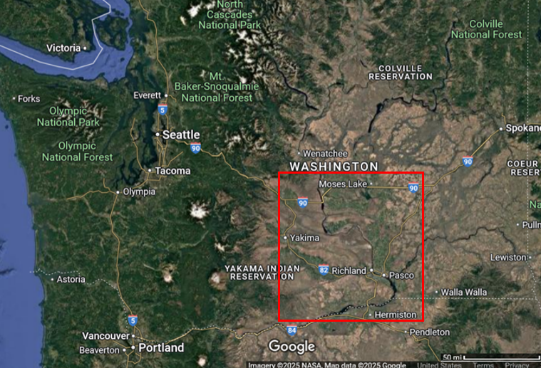
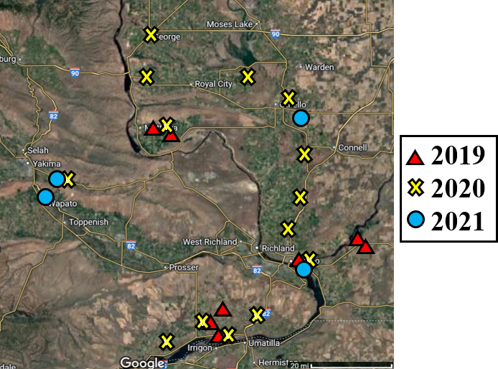
Figure 2
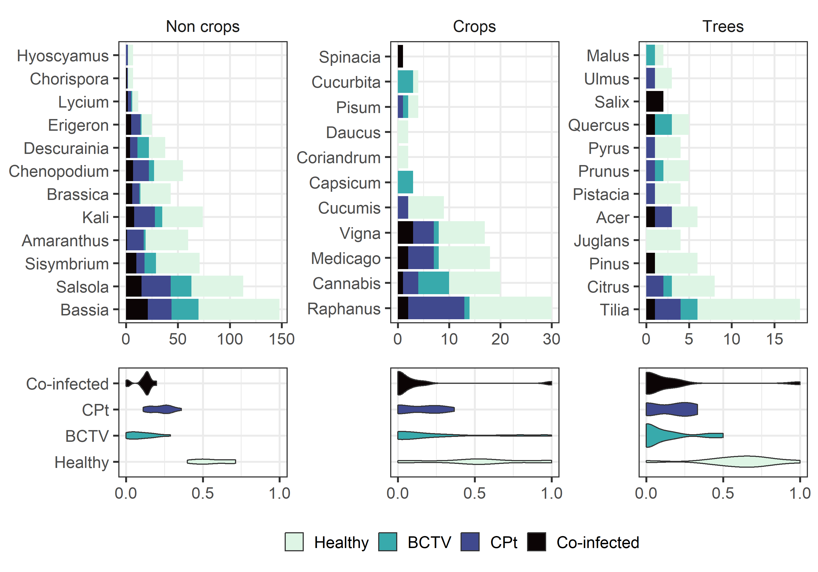

Figure 3
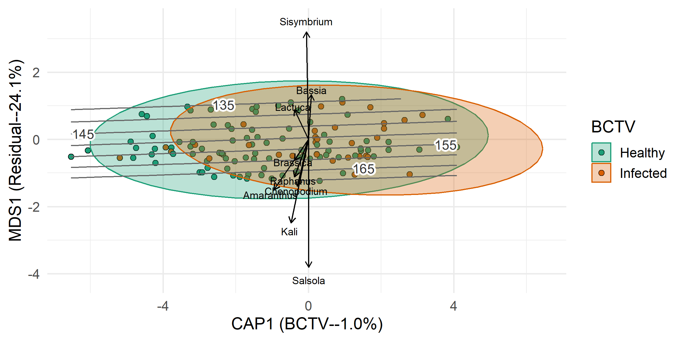

Figure 4
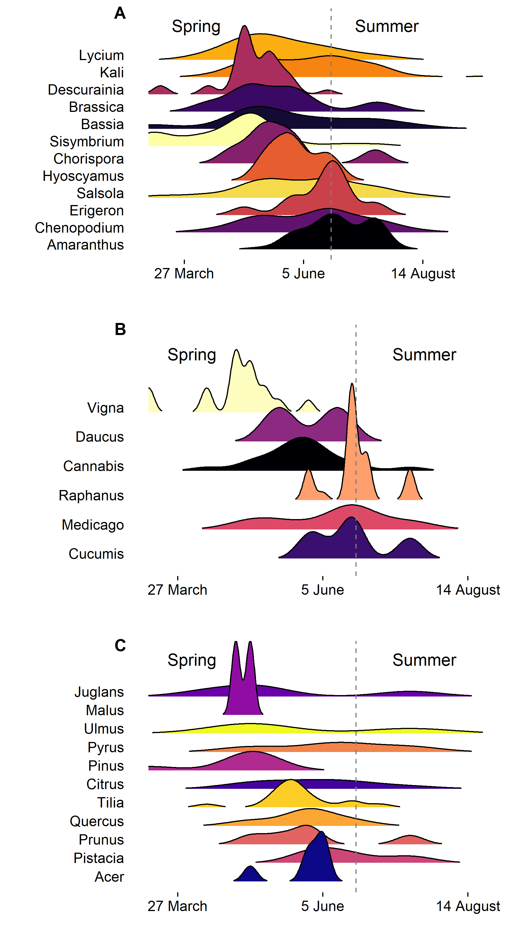
Acknowledgements:
Thanks to Heather Headrick at the USDA-ARS Wapato, WA lab and to Derek Pouchnik at the WSU Laboratory for Biotechnology and Bioanalysis Genomics Laboratory for their technical assistance. Special thanks to B.B. Porter.

References:
- Alkhatib BM, Belteton S, Creamer R. 2024. Immunolocalization of Beet Curly Top Virus
(BCTV) and GroEL chaperon protein of endosymbionts in beet leafhopper (Circulifer tenellus) vector tissue. Viruses. 16:1571. https://doi.org/10.3390/v16101571.
- Altschul SF, Gish W, Miller W, et al. 1990. Basic local alignment search tool. J. Mol. Biol. 215:403–410. https://doi.org/10.1016/S0022-2836(05)80360-2.
- Anderson MJ, Willis TJ. 2003. Canonical analysis of principal coordinates: a useful method of constrained ordination for ecology. Ecology. 84:511–525.
- Avanesyan A, Illahi N, Lamp WO. 2021. Detecting ingested host plant DNA in potato leafhopper (Hemiptera: Cicadellidae): potential use of molecular markers for gut content analysis. J. Econ. Entomol. 114:472–475.
- Bennett CW. 1971. The curly top disease of sugarbeet and other plants, Monograph No. 7. American Phytopathological Society; St. Paul (MN).
- Brewster CC, Allen JC. 1997. Spatiotemporal model for studying insect dynamics in large-scale cropping systems. Environ. Entomol. 26:473–482.
- Cici SZH, Van Acker RC. 2011. Relative freezing tolerance of facultative winter annual weeds. Can. J. Plant Sci. 91:759–763.
- Cooper WR, Horton DR, Wildung MR, et al. 2019. Host and non-host 'whistle stops' for psyllids: molecular gut content analysis by high-throughput sequencing reveals landscape-level movements of Psylloidea (Hemiptera). Environ. Entomol. 48:603–613.
- Cooper WR, Marshall AT, Foutz JJ, et al. 2022. Directed sequencing of plant specific DNA identifies the dietary history of four species of Auchenorrhyncha (Hemiptera). Ann. Entomol. Soc. Am. 115:275–284.
- Cooper WR, Walker WB, Angelella GM, et al. 2023. Bacterial endosymbionts identified from leafhopper (Hemiptera: Cicadellidae) vectors of phytoplasmas. Environ. Entomol. 52:243–253.
- Damos P. 2015. Modular structure of web-based decision support systems for integrated pest management: a review. Agron. Sustain. Dev. 35:1347–1372.
- Douglass JR, Hallock HC. 1957. Relative importance of various host plants of the beet leafhopper in southern Idaho. USDA Technical Bull. 1155.
- Foutz JJ, Wagstaff C, Cooper WR, et al. 2025. Weeding them out: identifying non-crop hosts and sources of infectious beet leafhopper, Neoaliturus tenellus (Hemiptera: Cicadellidae), in the Columbia River Basin. Environ. Entomol. https://doi.org/10.1093/aesa/saaf022
- Frantz R, Nischwitz C, Compton T, et al. 2023. Modeling the spread of curly top disease in tomatoes. Lett. Biomath. 10:53–61.
- Galinato SP. 2020. 2019 cost estimates of producing fresh and processing potatoes in Washington. Washington State University Extension; 67E.
- Gutiérrez Illán J, Bloom EH, Wohleb CH, et al. 2020. Landscape structure and climate drive population dynamics of an insect vector within intensely managed agroecosystems. Ecol. Appl. 30:e02056.
- Gutiérrez-López R, Bourret V, Loiseau C. 2020. Is host selection by mosquitoes driving vector specificity of parasites? A review on the avian malaria model. Front. Ecol. Evol. 8:569230. https://doi.org/10.3389/fevo.2020.569230.
- Han J, Cui M, Withycombe J, et al. 2024. Beet curly top virus affects vector biology: the first transcriptome analysis of the beet leafhopper. J. Genet. Virol. 105:7.
- Harveson RM. 2015. Beet curly top: America’s first serious disease of sugar beets. APS Features. https://www.apsnet.org/edcenter/apsnetfeatures/Pages/CurlyTop.aspx.
- Heck M. 2018. Insect transmission of plant pathogens: a systems biology perspective. mSystems. 3:e00168-17. https://doi.org/10.1128/mSystems.00168-17.
- Horton DR, Cooper WR, Grimm KS, et al. 2018. The beet leafhopper odyssey in North America: a brief overview. Potato Prog. 18:1.
- Knowlton GF. 1929. Studies on the morphology of the beet leafhopper. Bulletin No. 212.
- Koinuma H, Maejima K, Tokuda R, et al. 2020. Spatiotemporal dynamics and quantitative analysis of phytoplasmas in insect vectors. Sci. Rep. 10:4291. https://doi.org/10.1038/s41598-020-61042-x.
- Lee H, Wintermantel WM, Trumble JT, et al. 2025. Timing matters: remotely sensed vegetation greenness can predict insect vector migration and therefore outbreaks of curly top disease. J. Pest Sci. 98:607–617. https://doi.org/10.1007/s10340-024-01771-4
- Lee H, Wintermantel WM, Trumble JT, et al. 2022. Modeling and validation of oviposition by a polyphagous insect pest as a function of temperature and host plant species. PLoS One. 17:e0274003. https://doi.org/10.1371/journal.pone.0274003
- Meyerdirk DE, Moratorio MS. 1987. Circulifer tenellus (Baker), the beet leafhopper (Homoptera: Cicadellidae): laboratory studies on fecundity and longevity. Can. Entomol. 119:443–447. https://doi.org/10.4039/Ent119443-5
- Meyerdirk DE, Hessein NA. 1985. Population dynamics of the beet leafhopper, Circulifer tenellus (Baker), and associated Empoasca spp. (Homoptera: Cicadellidae) and their egg parasitoids on sugar beets in southern California. J. Econ. Entomol. 78:346–353.
- Munyaneza JE, Crosslin JM, Upton JE. 2006a. Beet leafhopper (Hemiptera: Cicadellidae) transmits the Columbia Basin potato purple top phytoplasma to potatoes, beets, and weeds. J. Econ. Entomol. 99:268–272.
- Munyaneza JE, Crosslin J, Jensen AS, et al. 2006b. Beet leafhopper and potato purple top disease: 2005 season recap and new research directions. In: 45th Annu. Proc. Wash. State Potato Conf. p. 107–118.
- Nachappa P, Fulladolsa AC, Stenglein M. 2020. Wild wild west: emerging viruses and viroids of hemp. Outlooks Pest Manage. 31:175–179.
- Nault LR, Ammar ED. 1989. Leafhopper and planthopper transmission of plant viruses. Annu. Rev. Entomol. 34:503–529.
- Oksanen J, Simpson G, Blanchet F, Kindt R, Legendre P, et al. 2024. vegan: community ecology package. R package version 2.6-6.1. https://CRAN.R-project.org/package=vegan
- Perilla-Henao LM, Casteel CL. 2016. Vector-borne bacterial plant pathogens: interactions with hemipteran insects and plants. Front. Plant Sci. 7:1163. https://doi.org/10.3389/fpls.2016.01163.
- Pitt WJ, Cooper WR, Pouchnik D, et al. 2024. High-throughput molecular gut content analysis of aphids identifies plants relevant for potato virus Y epidemiology. Insect Sci. 31:1489–1502. https://doi.org/10.1111/1744-7917.13327.
- R Core Team. 2023. R: a language and environment for statistical computing. R Foundation for Statistical Computing; Vienna, Austria. https://www.R-project.org/.
- Rafter MA, Walter GH. 2020. Generalizing about generalists? A perspective on the role of pattern and process in investigating herbivorous insects that use multiple host species. Arthropod Plant Interact. 14:1–20.
- Rondon SI, Murphy AF. 2016. Monitoring and controlling the beet leafhopper Circulifer tenellus in the Columbia Basin. Am. J. Potato Res. 93:80–85.
- Ruiz-Villalba A, Ruijter JM, van den Hoff MJB. 2021. Use and misuse of Cq in qPCR data analysis and reporting. Life (Basel). 11:496. https://doi.org/10.3390/life11060496.
- Scott DW. 1992. Multivariate density estimation: theory, practice, and visualization. Wiley Publishers; New York (NY). 360 p.
- Soto MJ, Gilbertson RL. 2003. Distribution and rate of movement of the curtovirus beet mild curly top virus (Geminiviridae) in the beet leafhopper. Phytopathology. 93:478–484.
- Strausbaugh CA, Wenninger E, Jackson L, Vincill E. 2024. Host and shelter plants for the beet leafhopper, which vectors curly top viruses and phytoplasmas in southern Idaho. PhytoFrontiers. 4. https://doi.org/10.1094/PHYTOFR-03-24-0022-R.
- Strausbaugh CA, Wintermantel WM, Gillen AM, Eujayl IA. 2008. Curly top survey in the western United States. Phytopathology. 98:1212–1217.
- Swisher Grimm KD, Crosslin JC, Cooper WR, et al. 2021. First report of curly top of Coriandrum sativum L. caused by beet curly top virus in the Columbia Basin of Washington State. Plant Dis. 105:3313.
- Swisher Grimm KD, Gorman CJ, Crosslin JM. 2023. New assays for rapid detection of beet leafhopper-associated plant pathogens, 'Candidatus Phytoplasma trifolii', beet curly top virus, and Spiroplasma citri. Plant Dis. 107:3958–3966. https://doi.org/10.1094/PDIS-04-23-0769-RE.
- Suzuki S, Oshima K, Kakizawa S, et al. 2006. Interaction between the membrane protein of a pathogen and insect microfilament complex determines insect-vector specificity. Proc. Natl. Acad. Sci. USA. 103:4252–4257.
- Thapa I, Ghersi D. 2023. Modeling preferential attraction to infected hosts in vector-borne diseases. Front. Public Health. 11:1276029. https://doi.org/10.3389/fpubh.2023.1276029.
- Thomas PE, Boll RK. 1977. Effect of host preference on transmission of curly top virus to tomato by the beet leafhopper. Phytopathology. 67:903–905.
- Weintraub PG, Beanland L. 2006. Insect vectors of phytoplasmas. Annu. Rev. Entomol. 51:91–111.
- Wickham H, Averick M, Bryan J, et al. 2019. Welcome to the tidyverse. J. Open Source Softw. 4:1686.
- Wilke C. 2024. ggridges: ridgeline plots in 'ggplot2'. R package version 0.5.6. https://CRAN.R-project.org/package=ggridges
- Wohleb CH, Waters TD, Crowder DW. 2021. Decision support for potato growers using a pest monitoring network. Am. J. Potato Res. 98:5–11.
- Wood S, Scheipl F. 2020. gamm4: generalized additive mixed models using ‘mgcv’ and ‘lme4’. R package version 0.2-6. https://CRAN.R-project.org/package=gamm4

